BIO for HPS/ANS Conference:

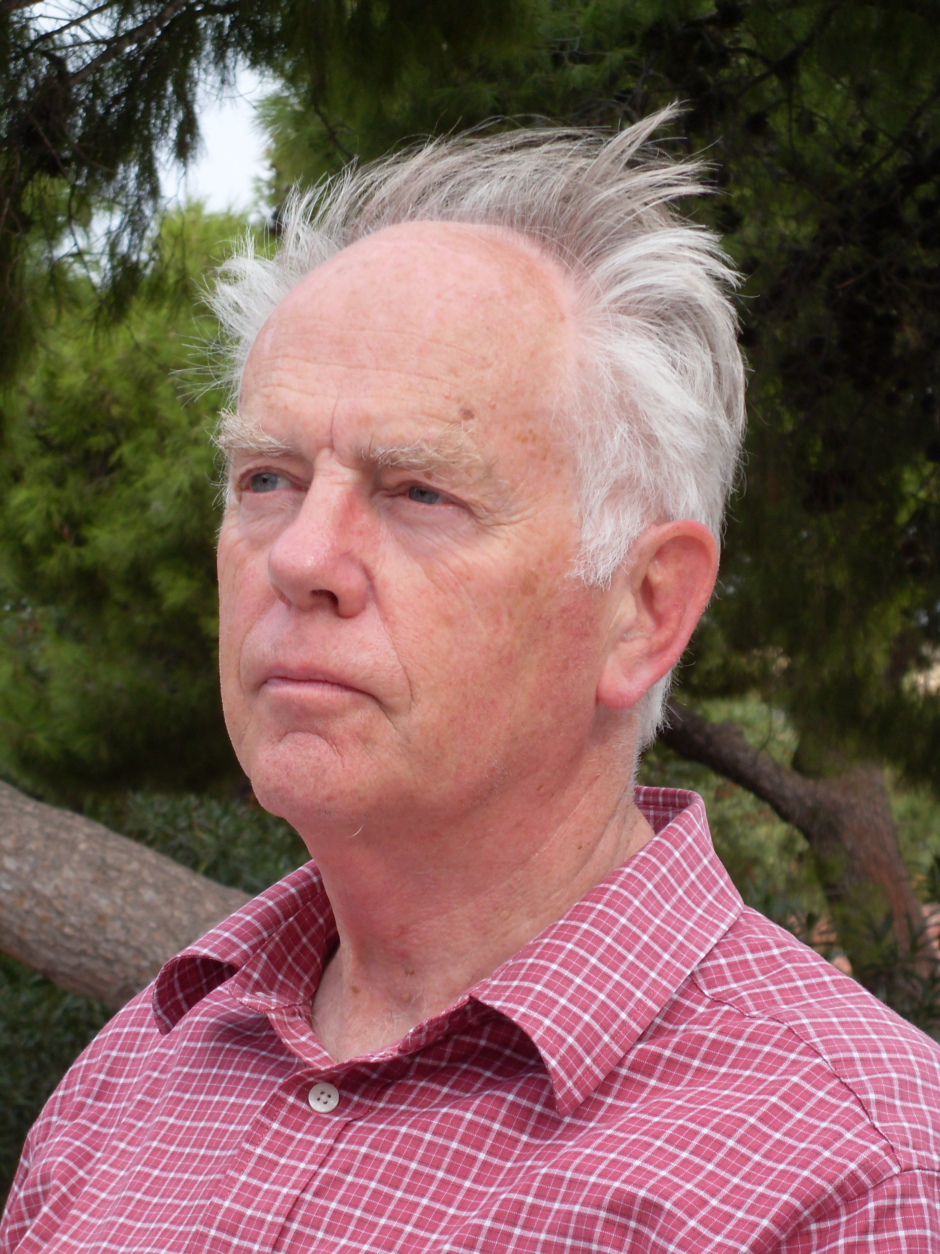
WADE W. M. ALLISON, MA, DPhil

Wade W. M. Allison, Honorary Secretary of Supporters Of Nuclear Energy in UK, is Emeritus Professor of Physics and Fellow of Keble College at the University of Oxford, where he spent his career researching in Particle Physics at CERN and elsewhere. At Oxford he taught courses from Mathematics and Statistics to Nuclear and Medical Physics, and published an advanced textbook “Fundamental Physics for Probing and Imaging” (Oxford, 2006). More recently he has devoted himself full time to countering nuclear phobia and its prevalence, not only in the public, but among engineers, physicists, doctors and other scientists whose experience is hampered by the divide between the physical and biological sciences. His two books “Radiation and Reason” (2009) and “Nuclear is for Life” (2015) engage this problem, its causes and consequences, in rigorous but accessible terms.

