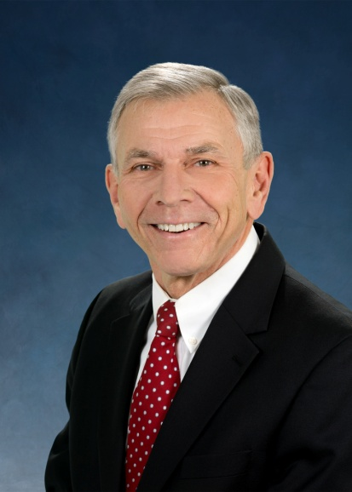

Mike Lawrence

Mike Lawrence is retired after 42 years in the nuclear industry, with senior management positions in government and the private sector in the United States and Europe. He was Manager of the Hanford Nuclear Site for the U.S. Department of Energy; Counselor of Nuclear Policy for the U.S. State Department in Vienna, Austria; Associate Laboratory Director at Pacific Northwest National Laboratory; and Director of the National Nuclear Laboratory in the U.K. He has a B.S. in Physics from the University of Maryland.

