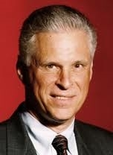
PAUL G. LORENZINI, Ph.D, J.D.
Paul G. Lorenzini has been involved in the controversy over nuclear power since the early 1970’s. In 1976 he served as Co-Chair of the No on 15 campaign which defeated an anti-nuclear initiative in California; in 1977-79 he represented intervenors in an Oregon administrative proceeding to support nuclear projects in Eastern Oregon; and he led efforts to organize an Oregon and Washington “Voice of Energy” in 1979-1981. In 1979 he joined Rockwell International’s Hanford Operation, serving as overall General Manager of its 5000-person operation from 1983-1987. He served in executive roles at PacifiCorp from 1987 until he retired in 2000. In 2007, he came out of retirement to co-found NuScale Power, which he led until he retired in 2013. He holds a Ph.D. in nuclear engineering from Oregon State university and a J.D. from Loyola Law School.

