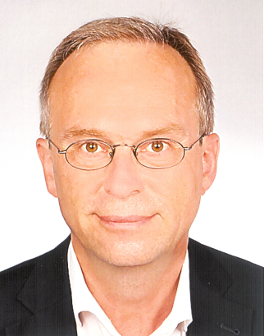

Werner Rühm
Werner Rühm is working at the Helmholtz Center Munich, Germany, where he is acting director of the Institute of Radiation Protection and leading the Medical and Environmental Dosimetry Group. In addition he is professor at the Medical Faculty of the University of Munich. Since 2016 he serves as Chair of ICRP Committee 1 on “Radiation Effects”. Currently he is chairing ICRP Task Group TG91 on low-dose and low-dose-rate effects. Since 2005 he is serving as Editor-in-Chief of the Radiation and Environmental Biophysics journal. In 2014 he was elected Chair of the European Radiation Dosimetry Group (EURADOS), and in 2017 he was appointed as a member of the German Radiation Protection Commission (SSK). In November 2017 he was appointed Co-chair of the SC1-26 Scientific Committee of the US National Committee on Radiation Protection and Measurements. Werner Rühm has published on various topics including quantification of neutron exposure of atomic bomb survivors, cosmic-ray exposure of air crew, risks from low-dose-rate exposures, behavior of radionuclides in the environment, internal exposures from incorporated radionuclides, and radiation measurement techniques.

